**Name:** HRISAV BHOWMICK

**UID:** A20011

**Use collection "transactions" created by importing "transactions.json" on day 2**

mongoimport --db transac --jsonArray --collection transactions --file E:\Praxis\Classroom\BDSN\NoSQL\1\transactions.json

show dbs

use transac

show collections

db.transactions.find().pretty()

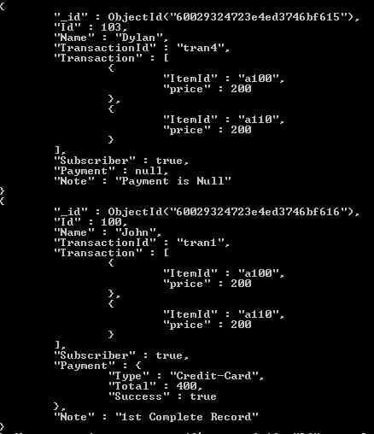

**# 1. Calculate the total transaction amount by aggregating Payment. Total in all records**

db.transactions.aggregate(

{$match: {}},

{$group: {_id: "Id", total_pay: {$sum: "$Payment.Total"}}},

{$project: {_id: 0, total_pay: 1}}

)

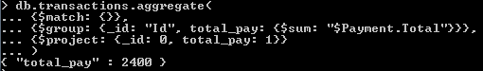

**# 2. Aggregate per record by aggregating Transaction.price**

db.transactions.aggregate(

{$project: {transaction_price: {$sum: "$Transaction.price"}}}

)

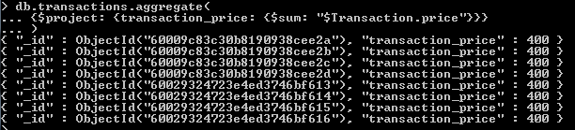

**# 3. Aggregate per payment type by adding up Payment.Total**

db.transactions.aggregate(

{$group: {_id: "$Payment.Type", total_pay_by_type: {$sum: "$Payment.Total"}}}

)

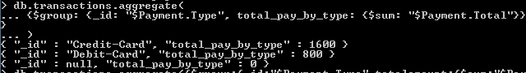

**# 4. Find the max id**

db.transactions.aggregate(

{$group: {_id: "null", max_id: {$max:"$Id"}}},

{$project: {_id: 0, max_id: 1}}

)

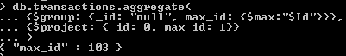

**# 5. Find the max Transaction.price**

db.transactions.aggregate(

{$group: {_id: "Transaction", max_transac: {$max:{$max:"$Transaction.price"}}}},

{$project: {_id: 0, max_transac: 1}}

)

